What is Databricks Delta Lake?
Databricks Delta Lake is an open-source storage layer developed by Databricks that sits on top of a data lake and brings the reliability and performance features of a database or data warehouse to it.
Delta Lake = Data Lake + ACID Transactions + Reliability + High Performance

1. Database
- Used for day-to-day applications.
- Handles transactions (insert, update, delete).
- Example: Banking systems, e-commerce orders.

2. Data Warehouse
- Designed for business intelligence and reporting.
- Stores cleaned and structured historical data.
- Example: Sales dashboards, monthly reports.

3. Data Lake
- Stores huge amounts of raw data (CSV, JSON, images, videos, logs).
- Cheap and scalable.
- Lacks transaction support and can become a data swamp if unmanaged.

4. Delta Lake
Delta Lake is an open-source storage layer developed by Databricks that sits on top of a data lake and adds:
- ACID transactions
- Schema enforcement and evolution
- Data versioning (Time Travel)
- Efficient updates and deletes
- Scalable batch and streaming processing
- High reliability

1. Traditional Data Lake

Applications / Analytics
|
Apache Spark / SQL
|
----------------
| Data Lake |
----------------
|
------------------------------------
| CSV | JSON | Images | Videos | Logs |
------------------------------------
Problems:
❌ No ACID transactions
❌ No update/delete support
❌ Data inconsistency
❌ Duplicate data
❌ Difficult schema management

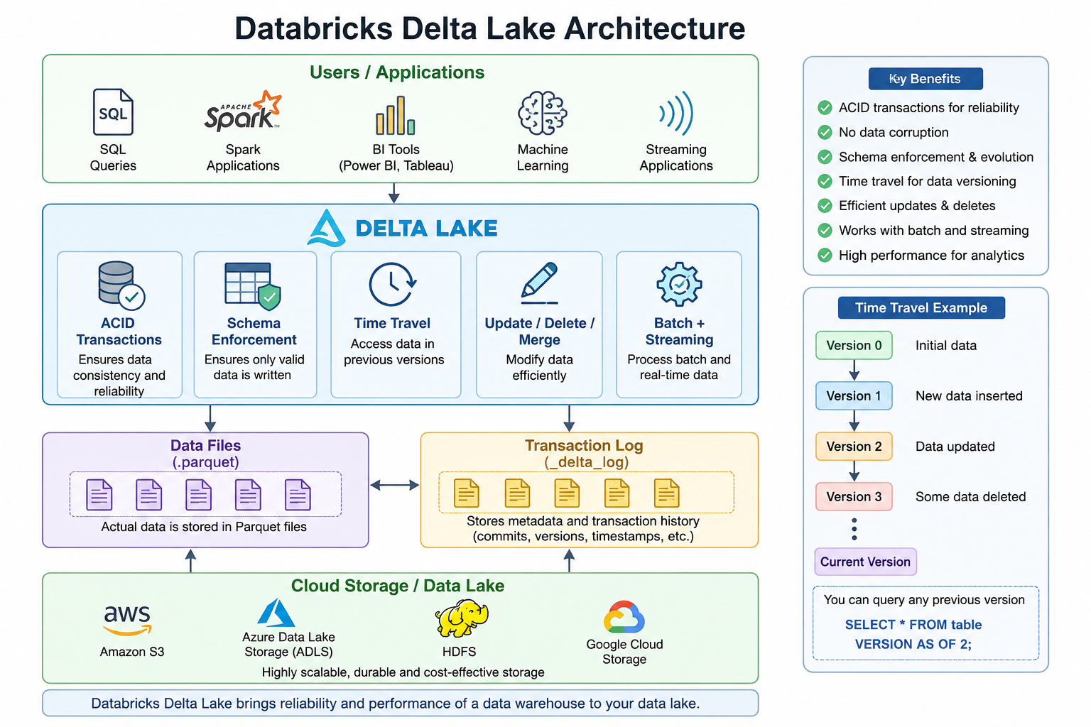

1. Users and Applications
Various tools and applications interact with Delta Lake, including:
- SQL Queries for data analysis.
- Apache Spark Applications for large-scale data processing.
- BI Tools such as Power BI and Tableau for reporting and visualization.
- Machine Learning Models for predictive analytics.
- Streaming Applications for processing real-time data.
These users and applications access data through the Delta Lake layer.

2. Delta Lake Layer
The Delta Lake layer provides advanced capabilities that are not available in traditional data lakes.

ACID Transactions
Delta Lake guarantees Atomicity, Consistency, Isolation, and Durability (ACID), ensuring reliable and consistent data even when multiple users access it simultaneously.

Schema Enforcement
It validates incoming data before writing, preventing incorrect or inconsistent data from being stored.

Time Travel
Delta Lake maintains previous versions of data, allowing users to retrieve historical records and restore earlier states if necessary.

Update, Delete, and Merge Operations
Unlike traditional data lakes, Delta Lake supports modifying existing records efficiently through SQL operations such as UPDATE, DELETE, and MERGE.

Batch and Streaming Processing
It supports both batch workloads and real-time streaming using the same storage layer.

3. Data Files (.parquet)
Actual data is stored in Parquet files, which are columnar storage files optimized for high-speed analytics and efficient compression.
Example:
Customer ID | Name | City
101 | John | New York
102 | Bob | Chicago
These records are physically stored in Parquet format.

4. Transaction Log (_delta_log)
Delta Lake maintains a special directory called _delta_log, which stores:
- Metadata about tables.
- Commit history.
- Versions of data.
- Information about inserted, updated, and deleted records.
The transaction log enables:
- ACID transactions.
- Time travel.
- Data consistency and reliability.

5. Cloud Storage / Data Lake
At the bottom layer, Delta Lake stores data in cloud storage systems such as:
- Amazon S3
- Azure Data Lake Storage (ADLS)
- HDFS
- Google Cloud Storage (GCS)
These storage systems provide highly scalable and cost-effective storage.

Time Travel Example
Suppose:
- Version 0: Initial data.
- Version 1: New records inserted.
- Version 2: Existing data updated.
- Version 3: Some records deleted.
Delta Lake preserves all versions, allowing users to query a previous state using:
SELECT * FROM table VERSION AS OF 2;
This feature is called Time Travel and is useful for auditing, debugging, and recovering deleted data.

Comparison: Database vs Data Warehouse vs Data Lake vs Delta Lake

Feature | Database | Data Warehouse | Data Lake | Delta Lake
Purpose | Transaction processing | Analytics and reporting | Store large volumes of raw data | Reliable analytics and storage
Data Type | Structured | Structured | Structured, Semi-structured, Unstructured | Structured, Semi-structured, Unstructured
Schema | Schema-on-Write | Schema-on-Write | Schema-on-Read | Schema-on-Write + Schema Evolution
Storage Format | Tables | Tables | Files (CSV, JSON, Images, etc.) | Parquet Files + _delta_log
ACID Transactions | ✅ Yes | ✅ Yes | ❌ No | ✅ Yes
Update/Delete Support | ✅ Yes | Limited | ❌ No | ✅ Yes
Time Travel | ❌ No | ❌ No | ❌ No | ✅ Yes
Batch Processing | Limited | ✅ Yes | ✅ Yes | ✅ Yes
Streaming Support | ❌ No | Limited | Limited | ✅ Yes
Performance | High | High for analytics | Moderate | High
Examples | MySQL, Oracle | Snowflake, Redshift | Amazon S3, Azure Data Lake | Databricks Delta Lake

